1.

import java.util.Scanner;

public class Week{

public static void main(String[] args){

Scanner obj = new Scanner(System.in);

String day = obj.nextLine();

switch (day) {

case "Monday":

case "Tuesday":

case "Wednesday":

case "Thursday":

case "Friday":

System.out.println("It's a weekday");

break;

case "Saturday":

case "Sunday":

System.out.println("It's a weekend");

break;

default:

System.out.println("Invalid day");

break;

}

}

}

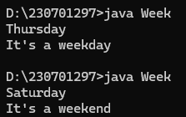

2.

import java.util.Scanner;

public class number {

public static int factorial(int num) {

int factorial = 1;

for(int i = 1; i<num; i++) factorial += factorial\*i;

return factorial;

}

public static void main(String args[]) {

Scanner sc = new Scanner(System.in);

int num = sc.nextInt();

int n = num;

int sum = 0;

while(num !=0 ) {

int rem = num % 10;

sum += factorial(rem);

num /= 10;

}

if(sum == n) System.out.println("Strong number");

else System.out.println("Not a strong number");

}

}

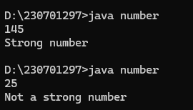

3.

import java.util.Scanner;

public class Pyramid {

public static void main(String args[]) {

Scanner sc = new Scanner(System.in);

int n = sc.nextInt();

for(int i=n-1; i>=0; i--) {

int num = n - (n-1);

for(int j=i; j>=0; j--) {

System.out.print(num + " ");

num++;

}

System.out.println();

}

}

}

